Mrs. Hester Jackson, nee Sowdon

Stage name Miss Brown 1751—1806
actress, singer, dancer.

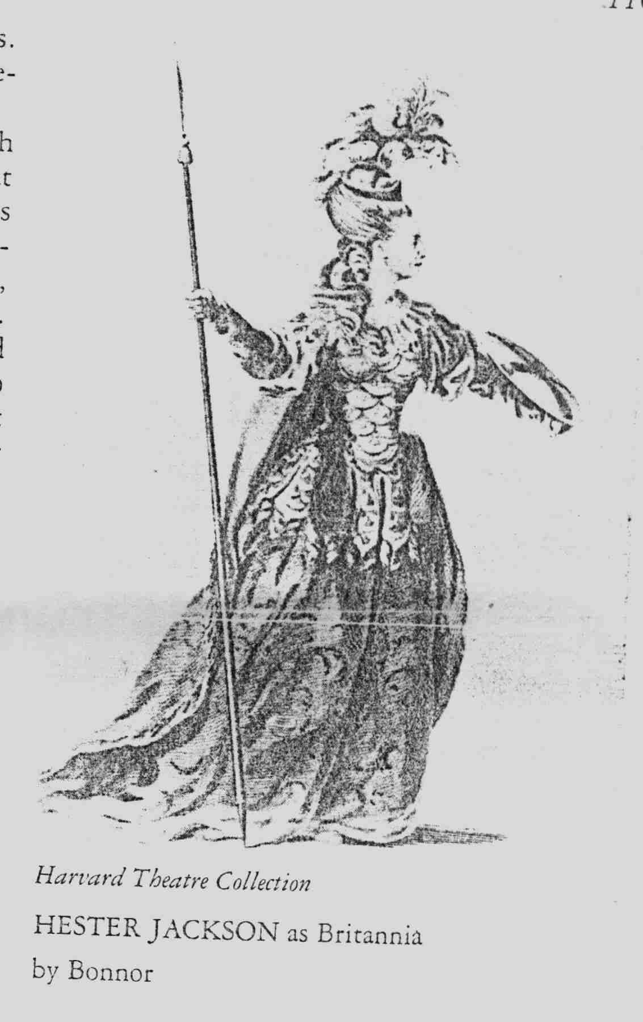
The actress and singer Hester Jackson, the wife of the Scottish manager John Jackson (1730—1806), was the daughter of John Sowdon (died 1789), a London actor and sometime manager of smock Alley Theatre in Dublin during the 175’s.

Her father adopted the name of Sowdon, probably to save his parents embarrassment, for according to the Dublin Journal of 5-9 June 1753, he came of a good family, being brother to “Thomas Otway of Castle Otway, Esq.” When Hester went upon the stage she adopted the professional name of Brown. According to the registrar of her burial in January 1806, Hester died at the age of 55 years; thus she was born in 1751 (her obituary in the Scott’s Magazine for January 1806 also stated that she died at 55, but claimed she was the daughter of an actor named Brown).

Some uncertainty surrounds Hester’s early career. We do not believe that she was the Miss Brown who acted Isabella in a performance of Cleone given by children at the Haymarket Theatre in 10th. May 1759, or the Miss Brown who was popular singer at Sadler’s Wells between 1762—1767. More likely, Hester made her debut not in London, but in Dublin, where she appeared first as Polly in The Beggar’s Opera.

At the smock Alley Theatre in January 1767. Several years later she made her first appearance in Edinburgh under Ross’s management at the New Concert hall as Thamyris in The Royal Shepherd on 26th. January 1769 and repeated that role in 20th. January and 21st. March. At Edinburgh that winter season she also played Harriet in The Jealous Wife on 13th. March, Ophelia to her future husband’s Hamlet on 15th. March, Angelica in The Constant Couple on 23rd. March, and Harriet in The Guardian ( with Jackson in the title role) and Polly in The Beggar’s Opera on 25th March. In his History of the Scottish Stage, John Jackson claimed to have acted Romeo to his future wife’s Juliet about that time.

Sometime shortly before 31st. July 1769, Hester married John Jackson in Ireland, for on that date she played Polly at Cork, announced as Mrs. Jackson from Edinburgh, Back at Edinburgh on 18th November 1769, the opening night of the New Theatre Royal in Shakespeare Square, advertised as Mrs. Jackson, she acted Desdemona to her husband’s Iago. During that 1769—70 season she was also seen a Belvidera in Venice Preserve’d, Charlot in The Lame Lover ,
Clarlotta in The Apprentice, Miss Lucy in The Virgin Unmask’d , Sally in Thomas and Sally. and Ophelia in Hamlet.

In May 1771 the Jackson’s returned to Dublin to act at the Crow Street Theatre. During the early 1770’s they played regularly in Dublin and Edinburgh. Among her numerous known roles in Edinburgh were Andromache in The Distrest Mother, Belinda in The Old Batchelor, and Lady Charlotte in The Funeral. They played at York in May 1774, she having a benefit there on the twentieth, the last night of their engagement. In December of 1774 they were with Younger’s company at Liverpool.

With her husband Mrs. Jackson was engaged by Foote in 1775 for his summer company at the Haymarket in London. There she made her first appearance on 7th. July as Edwena ( and spoke the epilogue) in Jackson’s tragedy Eldred. She had performed the role in Edinburgh on 19th March 1774 and perhaps previously in Dublin

Performances in Eldred on 10th and 14th July were her only others that summer. She was taken on for the following season at Convent Garden, where, on 25th September 1775, she first appeared as Juliet to Lewis’s Romeo and danced a minuet in a masquerade scene with D’Egville in Act.1
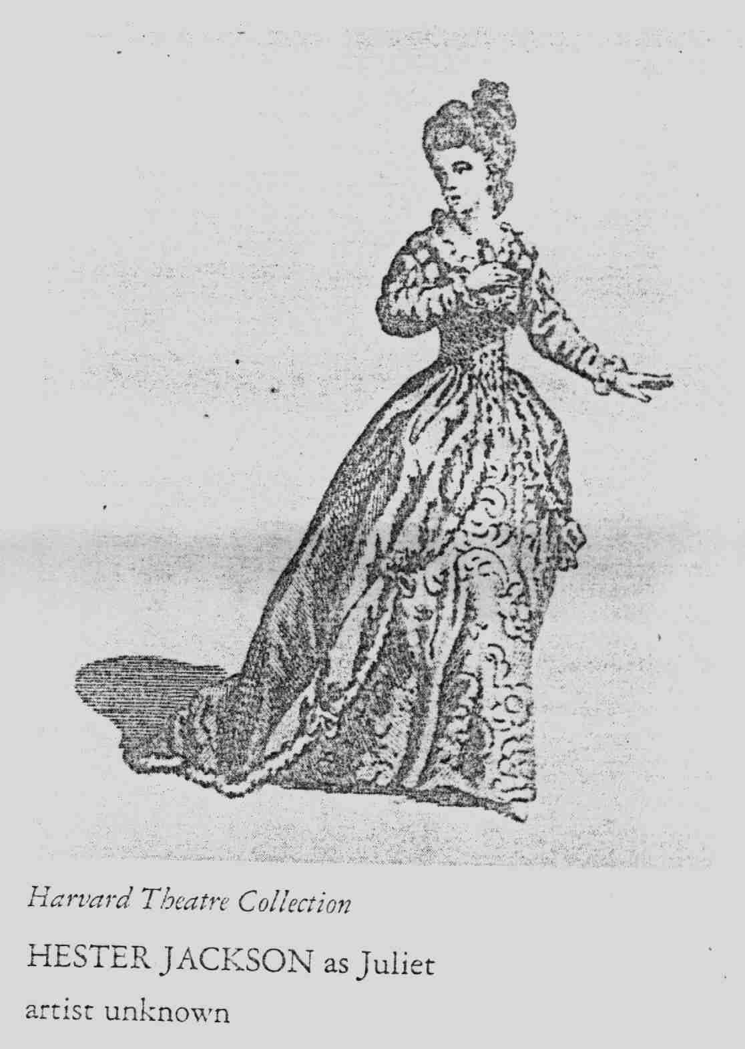
The Westminster Magazine for that month, identifying her as the lady which had performed in her husband’s tragedy at the Haymarket, found her extremely stiff in her delivery and action, but believed that if she could “divest herself of stage formalities, there would be fewer Juliet’s at either house, and she would prove a very decent second-rate Actress

After performances of Juliet on 2nd. And 9th. October 1775, Mrs. Jackson continued in her Convent Garden debut season with appearances as Rosetta in Love in a Village, Selima in Tamerlane, Queen Catherine in Henry VIII, Daphne in Midas, Lucia in Cato, Indiana in The Conscious Lovers, Cynthia in The Double Dealer, and Polly in The Beggar’s Opera. For her benefit on 1st. May1776 she acted Edwena, and her husband (who was not a regular member of the Covent Garden Company) acted the title role in his Eldred.
She went to Bristol with him in the summer of 1776 (and in 177); she returned to work at Covent Garden for another four seasons without her husband, who was resigned to the provinces. Among her more important roles during that period were Queen in Richard III, Zelmira in Zenobia, the Lady in Comus, Isabella in Measure for Measure.

The Queen in Hamlet, the title role in Merope, The Countess of Somerset in Sir Thomas Overbury, Mrs. Bromley in Know Your Own Mind, Birtha in Percy, Cordelia in King Lear, Millwood in George Barnwell, and Mrs. Strickland in The suspicious Husband. On 28th December 1778 she acted Lady MacBeth.

Among the few pres comments on her was one in the Morning Chronicle in February 1777 which noted her beauty, abilities, and spotless private virtues.

For her benefit on 7th May 1777, when her address was in the Great Piazza, Convent Garden, she played Leonora in The Revenge and received net proceeds of some $125. That night her husband returned to London to play Zanga for her. A year later on 5th May1778 he played Hareb and she Gerilda in his tragedy The British Heroine (first offered in Crow Street by the title of Gerilda in 13^{t} January 1777) for her benefit when net receipts were a more modest $83. She acted Lady Randolph in Douglas for the first time for her benefit on 30th April 1779, when her address was still the Great piazza. She delivered the prologue, in the character of Britannia to the London premiers of Dodd’s farce Gallic Gratitude that night.

Several weeks later on 10th May 1779 Mrs. Jackson accommodated Fosbrook, the box keeper at Dury Lane, by playing Mrs. Strickland in The Suspicious Husband for his benefit, her only performance recorded at that theatre,

When John Jackson started to develop his northern theatrical empire in 1780 Mrs Jackson joined him in Edinburgh, were she acted regularly in the 1780’s and early 1790’s, at least through May 1794. She was also at Manchester in the summers of 1789 and 1790, and at York in 1791. Perhaps she was the Mrs. Jackson who played Queen Eleanor in King Henry II at the Haymarket on 26th December 1791, and acted at Cork in May and September 1796, and at Richmond in the summer of 1799.

Genest wrote that Mrs. Jackson” was a disagreeable actress.” But in his edition of Gallic Gratitude published in 1779, James Solas Dodd appended “Critical remarks on Mrs. Jackson’s performance of Lady Randolph in the tragedy of Douglas… April 30th 1779,” in which he wrote: “She possessed many requisites for the stage; a pleasing person, an expressive countenance, a voice, at once exceedingly powerful and melodious, a great variety of tones, an action; void of stiffness or extravagance. and a just conception of the sense or her Author”.
Hester Jackson died at Edinburgh on 7th January 1806.

The “recorder’s Book of the Calton Burying Ground” in the General Registry Office for Scotland notes her burial on the 13th. January; Esther Jackson Spouse of John Jackson Esq;. .of Theatre Royal died of decline of nature buried in his own ground Aged 55 years.”

Her husband followed her to the grave in the same ground within a year, dying on 4th December 1806, at the age of 76. Information on their children will be found in his notice,

An engraving by T Bonner of Mrs. Jackson in the character Britannia in Gallic Gratitude was published in 1779. A drawing in Indianan Ink by an unknown artist of her as Juliet is in the British museum; and engraving by an unknown engraver was published by F. Wenman in 1778.

A Sincere thank you to Yvonne Hands who found these pages and was kind enough to pass them on to include in the Four Jackson Sisters
M.M.

